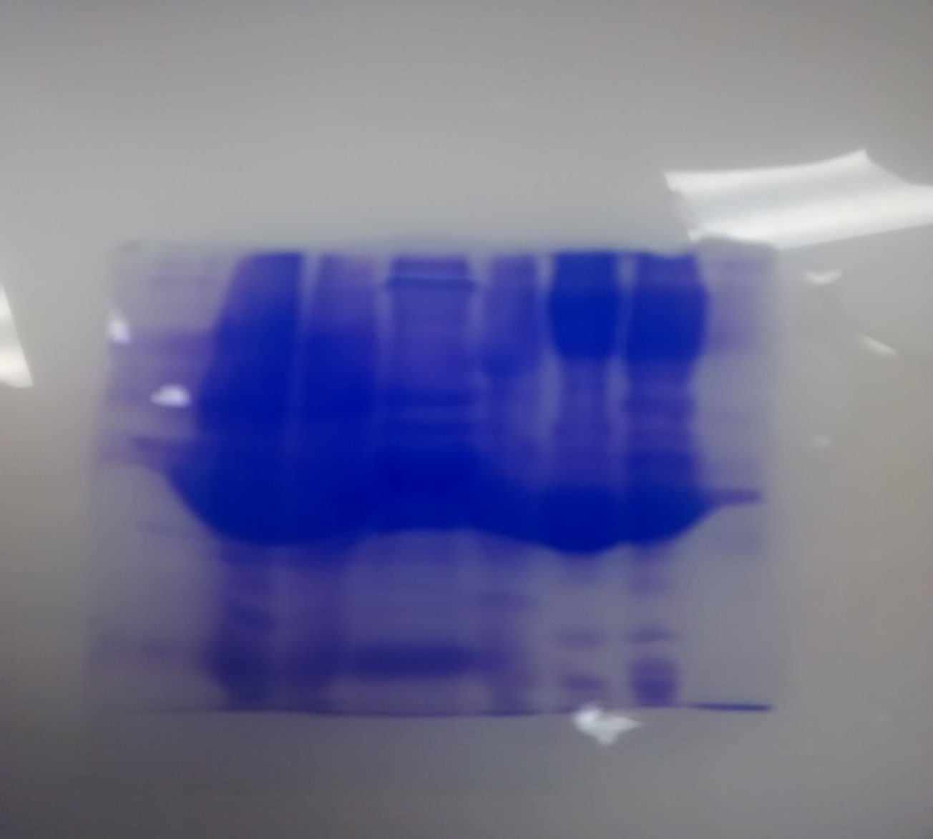
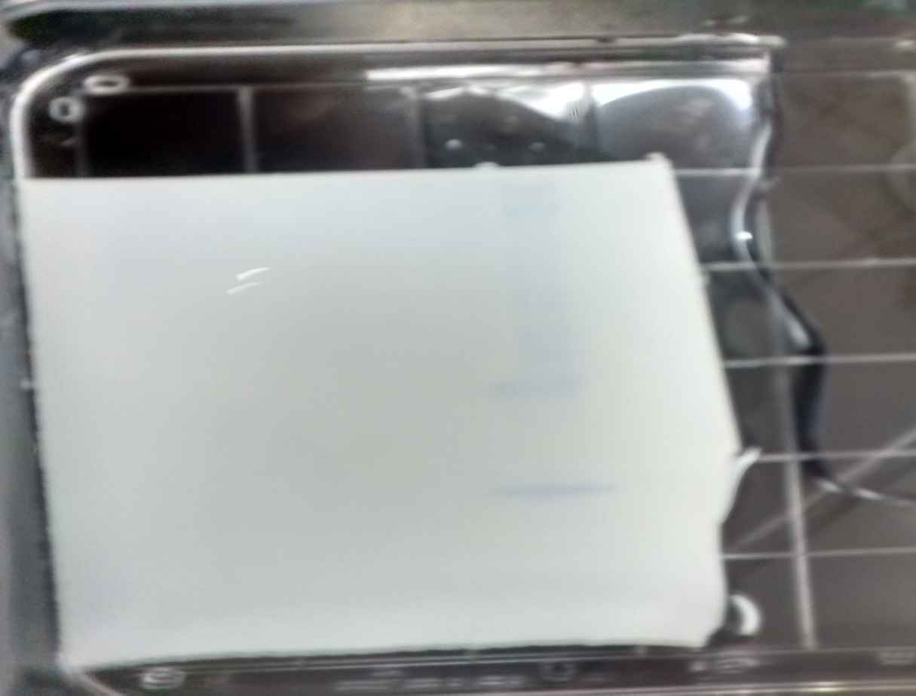
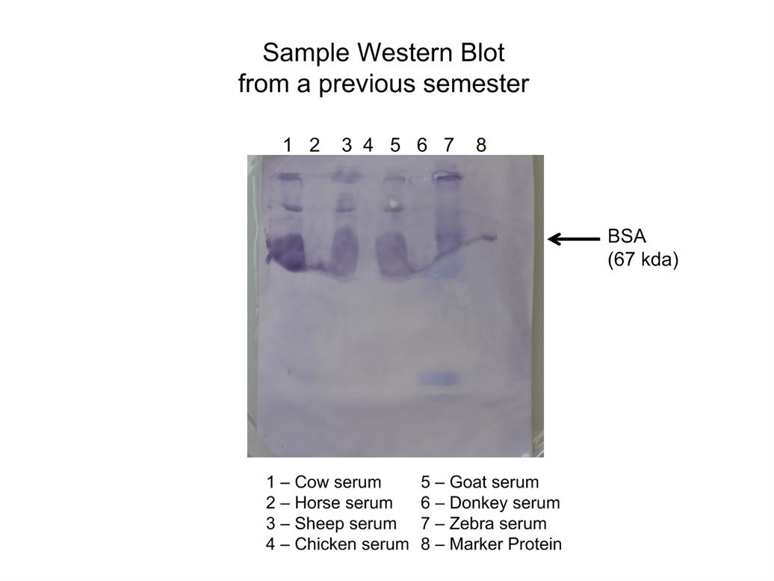
Taylor Goodwin, Bio377: Lab report 2, Spectroscopy, 1/17/17
Title with BSA Protein

Introduction
Grading Criteria
Protein quantification has a world of applications. It could be used in medicine to determine if a protein found in a sick subject’s blood (would be nice if you had a real-life example here – toxin, etc..) was formed by their body malfunctioning, or if it’s epitopes suggest a foreign origin. It has been used extensively in taxonomy to aid in suggesting most probably ancestry of an organism¹. Indeed, of late protein quantification and taxonomy have been used in concert to even determine protein function². And, in our case of use, it can be used to determine the relatedness of several differing organism’s protein types, namely of Bovine Serum Albumin (BSA) to other animal albumin allotypes. Nice intro!
3. Briefly explain the concept of protein quantification using a spectrophotometer
One can determine the concentration of protein in a solution by measuring the amount of light absorbed by the protein using a spectrophotometer. This value is compared to a standard curve of known concentration absorbance values thus allowing quantification. Two useful chomogenic techniques are the Bradford and Lowry methods. The Bradford requires only a single reagent and is completed in a mere 5 minutes. It is fast, easy and sensitive down to concentrations of 0.1 mg/mL. It may give variable results, however, as its reaction is specific to a few species of amino acids. The Lowry method takes only slightly longer at 15 minutes, uses two reagents and is also sensitive down to 0.1 mg/mL. It is less variable as it’s reaction involving the Cu⁺⁺ ion reacts with the free electron pairs of nitrogens, something every amino acid has.

5. Briefly explain the concept of electrophoresis, SDS - PAGE, and the difference between “native” and “denaturing” gels
Electrophoresis is the act of using a lattice-like gel substance and electrical charge to pull proteins through a gel, separating by size as the smaller proteins are able to move through the lattice of the gel more easily than the larger proteins. Shape of a protein also affects its speed of movement; the more balled up a protein the quicker it can move through the lattice. A gel that runs with both the native protein shape and size is called a Native Gel. Many times you wish to know only the difference in molecular weight. To remove the shape factor sodium dodecyl sulfate (SDS) can be included in the gel to change the normal, or “native” protein shape into a linear one, or in other words to denature the proteins. The only significant factor for speed of movement in this Denatured SDS Gel is then molecular weight of the protein.
6. Explain the significance of the Wes tern Blot and its application to this lab?
Western blotting allows macroscopic visualization of antibody attachment to its specific epitopes. In this lab we selected epitopes known to be found on Bovine Serum Albumin to allow us to ascertain if it was indeed present in the sample. In addition to this, if the antibody attaches to any other proteins besides BSA then a convincing conclusion that can be drawn is that these substances have highly similar epitopes, which suggests similar origins and a conservation of structure from the original source or ancestor.
7. Clearly state the objectives for all experiments shown in this report in the last paragraph (i.e. Why did you perform each experiment?) Don’t be vague in describing your objectives; be brief but specific
The objectives in our labs were as follows.
We aimed to compare Bradford and Lowery spectrophotometer techniques for accuracy in measure the concentration of IgG both with and without the presence of contamination to determine the best technique for measuring BSA concentrations. Following this we aimed to determine how conserved the albumin protein was, this was accomplished by using informatics compare amino acid sequences of BSA with other animal’s serum protein albumin. We also used denatured protein electrophoresis to learn how similar the sizes of various animal serum proteins compare with bovine serum albumin. Finally, we used western blot HRP antibody testing in order to determine that BSA was present, and perhaps to find any highly similar epitopes in other animals.
Brother Ririre: I’m not really sure what the point of these were, I’m guessing. Why did we care if BSA looked similar to other animals Albumin? Was this experiment to see how conserved the protein structure was? To determine how closely related the animals are? To tell if albumin is found in all animals? Can you help me see what the point was? So the overall point here was to see how conserved albumins are between different animal species. The Western blot lets you see their evolutionary relatedness because antibodies specific to cow may cross-react with other animals if the protein is conserved among those animals. You will then use your last figure with the T-Coffee results to drive this point home in the discussion later.

Materials and Methods
Quantifying BSA Protein Concentrations using the Bradford Method
The purpose of the experimental procedure was to quantify an unknown concentration of Bovine Serum Albumin (BSA) (BioRad) via spectroscopy (Thermospectronic Genesys 10uV) at an absorbance of 595nm. This was done by creating a standard curve of 100ul samples with BSA concentrations of 0.296, 0.444, 0.592, 0.740 and 0.888mg/ml. Samples contained BSA, ddH2O and Xml Bradford reagent (BioRad) (How much? A blank containing ddH2O and Bradford reagent was used. The unknown BSA concentration absorbance value was taken and the concentration calculated using beers law and the line equation generated by the standard curve. (Results? The 40% dilution was thrown out.)
Determining effects of Contaminants on IgG Quantitation using the Lowry Assay
The purpose of this experiment was to determine how much contaminants can alter the apparent concentration of a substance while using the Lowry method and taking absorbance at 750nm. This was done by creating a standard curve from five 100ul samples containing ddH2O, Lowery Reagent A (BioRad) and Lowery Reagent B (BioRad) (How much) with IgG concentrations of 0.294, 0.441, 0.588, 0.809, 0.882 in mg/mL. A blank containing ddH2O and both Lowery reagents was used. Following this, samples of five contaminants, 3% Anionic detergent (SDS), 1M Ammonium Sulfate (AS), 25mM Glucose (Glu), 25% Glycerol (Gly) and 25mM Ionic Chelator (EDTA) each with 0.735mg/mL concentrations of IgG were prepared. An uncontaminated sample of 0.735mg/mL IgG in ddH2Owas prepared as a control. Absorbance values were taken for each of the samples and the apparent IgG concentration calculated using beers law and the line equation generated by the standard curve.
Electrophoretic Separation and Comparison of Bovine Serum Albumin vs Other Animal Albumin Samples
The purpose of this experiment was to separate all serum proteins so the individual proteins could be probed specifically for the presence of BSA. To this end a 5% stacking and 12% running acrylamide SDS-PAGE gel was prepared. Wells 1 and 9 received 10ul of SMP Marker (Rockland) and AM Marker (Modern Biology) respectively while wells 2-7 and 9-15 were loaded with 10ul of (all animals listed) albumin serum samples (Modern Biology). The gel was run over 80 minutes in a gel electrophoresis apparatus (BioRad) at ~110uV. The gel was Coomassie stained over 48 hours and then was destained for 2 hours in methanol and acetic acid.
BSA Protein Identification and Cross Reactivity via Western Blot
The purpose of this experiment was to identify the presence of BSA and any cross reactivity in the gel samples prepared in the prior experiment. A western blot sandwich was stacked from using wells 9-15 from the above gel. The stacking order from bottom to top was: glass plate, filter paper, gel, nitrocellulose membrane (Modern Biology), filter paper, then glass plate. This was left in a bath of transfer buffer at room temperature for 48. A Ponceau stain was performed by taking the nitrocellulose membrane, rinsing it with ddH2O and then submerging it in Ponceau stain (Modern Biology) for 5 minutes. The membrane was then placed in an incubation tube with 2% gelatin buffer solution in rotisserie incubator for 30 min at 37 degrees Celsius. After the 30 minutes the blocking solution was removed and 8mL HRP Conjugated Anti-BSA Antibody solution at a concentration of 0.5 micrograms/mL (ICL) was added to the tube and placed back in the rotisserie incubator for 30 min at 37 degrees Celsius. After this the membrane was washed in three baths of TBS and NP4D then washed in straight TBS for about two minutes. The membrane was then submerged in 10mL of color development solution (Pierce) for about ten minutes.

Results
Quantifying Protein concentrations using Bradford Method
Figure 1 showing your standard protein curve using BSA with either the Bradford or Lowry assay ( whichever you were as signed - Part A of ch apter 7 – make sure your trendline equation and R 2 correlation are included ) .

2: Absorbance reading of the unknown concentration of BSA sample is provided in the text .
3. C alculated c oncentration of the unknown BSA sample using your assay i s provided in the text and accurate ly calculated from your standard trendline equation . [ Note the concentration of the unknown BSA sample given to you during lab; you must discuss how close your calculated value is to this concentration later in the “Disc ussion” portion of your report . ]
4. Calculated concentration of the unknown BSA sample from the group across from you (using their assay and standard curve ) is provided in the text ( you don’t need to show their standard curve ) .
5. Figure 2 showing your IgG pro tein standard curve with either Bradford or Lowry assay ( Part B of chap ter 7 - opposite assay from the one you used in Part A ) [ Note that you don’t have to show the other group’s standard curve .]
6. Fi gure 3 Bar - Graph that visually shows both Bradford & Lo wry results (yours & the group across from you) of the calculated apparent (“observed”) IgG concentrations (not absorbances) in the presence of each c ontamin ating substance. [ Make sure your axes are labeled properly (mg/ml IgG on the side and each contamin ant on the bottom). Also make sure all contaminants are defined in the figure caption along with the “known” final concentration of IgG that is common to all samples.) [ Note the purpose of your bar - graph is to show how close to the known concentration of IgG you and the other group agreed on is when using either a Bradford or Lowry assa y in the presence of a contaminant . In other words, you are trying to determine how much each contaminant affects a Bradford and Lowry assay’s ability to give you a correct concentration reading. Your observations on this must be discussed in the “Discussion” later . ]
7. State what the various animal serum samples were that you separated u sing SDS - PAGE electrophoresis and point out to the reader how well the proteins separated and which kd size range the majority of the proteins are at .
8. Figure 4 showing your c oomassie stained SDS - PAGE gel im age of separated serum proteins. [ Remember in the preceeding text you must point out how well your serum proteins separated after running the gel and staining with Coomassie (compared to the marker protein lanes) and t ell the re ade r what size ranges most serum proteins are migrate to . ]
9. Figure 5 that shows the results of the transferring your proteins from the gel to the nitrocellulose membrane based on Ponceau staining , [ Make sure in the preceeding text you let the reader know if you saw evidence of protei ns transferred onto the membrane and w hich lanes showed the most transfer ).
10. Figure 6 that shows the image of your Western blot. [ Ma ke sure in the preceeding text you point out to the reader where you see evidence of antibody bin ding and the name of the protein the antibody was specific to. C ross - reactive binding of antibody to proteins in other lanes should be pointed out to the reader.)
11. Figure 7 that shows the results ( about the first four lines of compared amino acid sequence ) from your bioinformatics T - Coffee p ileup analysis performed on the different animal albumins analyzed on your Western blot plus a few others . [ Make sure in the preceeding text you point out to the reader what this analysis did, but don’t interpret what it means. If an albumin sequence for a particular animal could not be found in the database then mention that in the preceeding text and caption .]
12. In the text preceeding all of the above results, please resist the temptation to be short and vague in your descriptions; it will cost you in your grade. Remember, you should never interpret the meaning or significance of the results in this section, just point out to the reader what’s important to notice . And always keep in mind if it is not clear to the instructor what you did in the experiment then you cannot expect someone who has never taken this course to understand
Companion group got .36 with Lowrey
We got concentration of .48 With Bradford.
Actual concentration was .49.

Standard curve. 40% point tossed as outlier.
Determining effects of Contaminants on Accuracy of Spectrophotometer Absorbance Readings

750nm
Fig 2 Standard curve

Contamination Bradford vs lowery comparison above
Electrophoretic Separation and Comparison of Bovine Serum Albumin vs Other Animal Albumin Samples
Point of experiment copied here

Blue coomassie pic (SDS-PAGE)
Note that the majority of proteins appear to run at 35-36 kd. BSA is roughly that size. Lane 1: SMP marker standard. 2: Chicken. 3: Sheep 4: Horse. 5: Cow. 6: Goat. 7: Donkey. (get real well values!!) Arrow notes BSA marker on within SMP standard.
BSA Protein Quantification via Western Blot

Ponceau stain pic above (reft email from scott)
No color found (see pic A, representative is pic B). Representative Western blot was provided, probing was positive (discussion says this means that albumin is positive)

Note that the majority of proteins appear to run at 35-36 kd. BSA is roughly that size. Lanes; 1: Cow. 2: Horse 3: Sheep. 4: Chicken. 5: Goat. 6: Donkey. 7: Zebra. 8: Marker Protein Standard. Arrow notes BSA marker on within SMP standard.
Discussion

Standard curve had 5 points, 40% point was tossed as outlier
(discussion These animals are likely related because of same conserved epitope, as seen in result having antibodies linking to more than only cows. Find online sources that back up this also. Wet lab, bioinformatics and online taxonomy)
Western blot
Note that lane 1 AM Marker spilled into lane 2 a very little bit

No color found (see pic A, representative is pic B). Perhaps gelatin masked epitopes.

Below is a sample of the amino acid comparison.
tr|A0A140T897|A DEKKFWGKYLYEIARRHPYFYAPELLYYANKYN
sp|P35747|ALBU_ DPDKFLGKYLYEVARRHPYFYGPELLFHAEEYK
tr|Q91134|Q9113 DRDSVLAQYIFELSRRYPTALSVVILESTKTYK
tr|I6QYU0|I6QYU NRASFMGHYIYEISRRHPLMYPPAILHMAHSFE
sp|P02768|ALBU_ NEETFLKKYLYEIARRHPYFYAPELLFFAKRYK
sp|Q5XLE4|ALBU_ DPDKFLGKYLYEVARRHPYFYGPELLFHAEEYK
cons : .. :*::*::**:* :* :. ::

tr|A0A140T897|A RQRLRCASIQKFGERALKAWSVARLSQKFPKAE
sp|P35747|ALBU_ KERLKCSSFQNFGERAVKAWSVARLSQKFPKAD
tr|Q91134|Q9113 EQEYTCYNLKKYGKDKLYALKFIETHEKFVNAK
tr|I6QYU0|I6QYU LQQHNCYILKNFKEETLKAVKLSQTAQKFPKAS
sp|P02768|ALBU_ KQRLKCASLQKFGERAFKAWAVARLSQRFPKAE
sp|Q5XLE4|ALBU_ KERLKCSSFQKFGERAFKAWSVARLSQKFPKAD
cons :. * :::: : . * . . ::* :*.

tr|A0A140T897|A AKYICDNQDTISSKLKECCDKPLLEKSHCIAEV
sp|P35747|ALBU_ AKYICEHQDSISGKLKACCDKPLLQKSHCIAEV
tr|Q91134|Q9113 SQYVCEHKDAISSNVGHCCEKPLVERPNCLATL
tr|I6QYU0|I6QYU TTKTCAKKDELSSKLPACCEKPIIERSACIVKM
sp|P02768|ALBU_ AKYICENQDSISSKLKECCEKPLLEKSHCIAEV
sp|Q5XLE4|ALBU_ TKYICEHQDSISGKLKACCDKPLLQKSHCIAEV
cons : * ::* :*.:: **:**::::. *:. :

Sources
1. Yu H, Jansen R, Stolovitzky G, Gerstein M. Total ancestry measure: Quantifying the similarity in tree-like classification, with genomic applications. Bioinformatics. 2007;23(16):2163-2173. https://academic.oup.com/bioinformatics/article-abstract/23/16/2163/197865/Total-ancestry-measure-quantifying-the-similarity. Accessed Feb 9, 2017. doi: 10.1093/bioinformatics/btm291.
2. Falda M, Lavezzo E, Fontana P, et al. Eliciting the functional taxonomy from protein annotations and taxa. Scientific Reports. 2016;6:31971. http://www.nature.com/srep/2016/160818/srep31971/full/srep31971.html. Accessed Feb 9, 2017. doi: 10.1038/srep31971.

